**Bug 1: The discount details are unclear - while the image displays 20%, the text indicates 30%**

Test Case: 13

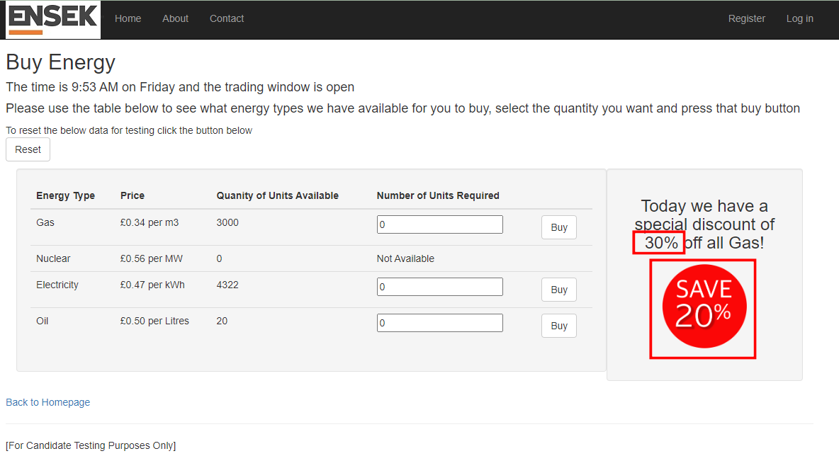

**Bug 2. Critical information is missing on the confirmed page - the price (amount spent)**

Test Case: 14

